Guided Capstone Project Report

The price per adult on a weekend for the resort depended on certain key parameters of it.

The vertical drop at the location with respect to the summit elevation of it is plotted below. As can be clearly seen the resorts can be broadly divided into 3 clusters.

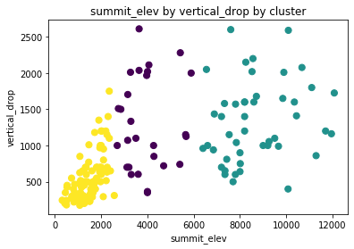

The Weekday vs Weekend plot below shows slight collinearity and the ratio between them is not huge clearly suggesting that if we were to change the weekend prices, the weekday price would also have to be changed.

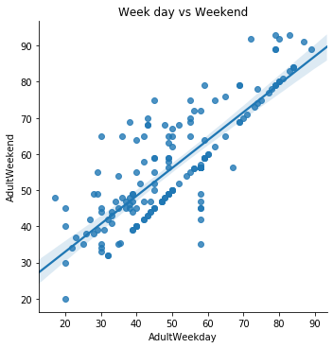

The number of quad lift chairs with respect to the weekend prices is plotted below. Only conclusion that too with a leap of faith can be drawn from this is number of quad lift-chair prompts the resort to increase their prices.

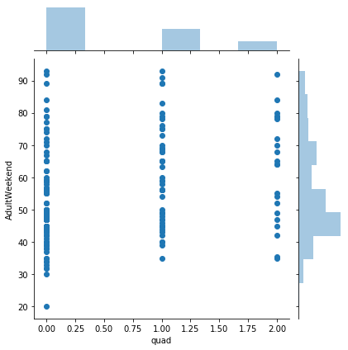

Hence after deploying the model we were able to predict the weekend prices for Monarch Mountain resort to be $599.